Thank you for participating!
We’re so excited to have you participate in our second Annual Slumber Party on Saturday, February 19th, 2022! We appreciate your commitment to helping Rescue Village’s homeless animals and it’s a testament that it really does take a village to make a difference.
We are here to help you every step of the way! If your question is not answered here, or if you have an idea you want to run by us, don’t hesitate to reach out.
Event and General Support
Jamie Smith | events@rescuevillage.org

About Rescue Village
Rescue Village, formerly known as the Geauga Humane Society, has been saving animals from homelessness, harm and performing lifesaving work throughout Geauga County and Northeast Ohio for more than 30 years. Our mission is to bring together organizations, businesses, and individuals across Northeast Ohio to work toward our shared vision of a more humane society. The current 19,000 square foot center includes a full-service veterinary clinic, a state-of-the-art shelter, an outdoor barn and trails to exercise the animals in our care. We rely 100 percent upon philanthropic donations to serve our mission. For more information visit rescuevillage.org.

Programs and services we offer to the community include:
Pet Adoption | Pets for the Elderly
Dog Training and Therapy | Spay/Neuter Programs
Education & Outreach Programs | Humane Law Enforcement and Education
Animal Transport | Programs for Veterans
Barn Animal Program  Community Guardian Program | Volunteer Opportunities  Pet Food Pantry

Campaign Overview
Our goal with this event is to raise $20,000 with the support of dedicated fundraisers like you. Every dollar raised will directly go toward the care of the shelter’s animals.
- $25 helps provide shelter, toys, and treats for animals in our care during their stay
- $75 will support a one week stay at the shelter for a dog or cat
- $150 will provide enough food for ALL the dogs and cats in our care for a full week
- $250 sponsors our humane agent for one day
- $500 will cover the ENTIRE cost of heartworm treatment for a heartworm positive dog
- $1000 will cover the cost of spay and neuter surgeries for 12 dogs, decreasing the amount of homeless animals and making more animals ready for adoptions
TIP: When asking for donations, it is sometimes helpful to give suggested amounts and what that donation provides. Feel free to use these breakdowns when asking family and friends to support you.

Why Sleep in a Dog Kennel?
Every dog and cat deserves our assistance to become more adoptable and to stay adoptable until he/she finds their forever home. Besides providing them with social interaction, spending time with a shelter dog/cat encourages them to interact politely and also helps them become more adoptable. You can make a difference in a shelter animal’s quality of life by adding enrichment with your time, attention and love.
The Slumber Party
For 12 hours on February 19th, you will be in a kennel with a Rescue Village shelter dog/cat. The space is not that big, and likely not the most comfortable, but it will help create awareness about what it’s like for our animals to be in the kennel, what goes into their care, and hopefully get a few of them adopted!
This is the second year Rescue Village is hosting this event and the participants last year all said it was an experience they will never forget. One participant commented-
“Staying in a shelter kennel for 12 hours had tough moments for me. But empathy is about connecting; it’s about feeling *with* someone. And it makes my heart swell to know how many people felt with us as we lived in the shelter, felt with the dogs who live there and those who still need rescuing, and who donated or otherwise contributed as a result.” – Taylor Snead, Maui Humane Society
We will be working with our Animal Care Team to ensure that both you and the animals feel safe during the night. There will be a dedicated space for you to store belongings and grab some dinner, drinks, and snacks that will be provided.
CHECKLIST
- Set your fundraising goal
- Create your online fundraiser on Facebook
- Customize your fundraiser page to tell your story
- Send emails to family and friends
- Consider asking for businesses that you support to sponsor you
- Communicate regularly
- Say Thank you!

Are you excited?
The key between now and February 19th are your efforts toward meeting your fundraising goal. Rescue Village’s External Affairs Team is here to help you along the way. We will cover fundraising in the next section.
Things you can begin to think about for the day of include:
- Will you be asking for donations the day of? Will you have challenges that you are willing to do as part of a donation ask?
- Engagement activities: the event will be live-streamed by RV on Facebook and we encourage each of you to stream and share updates directly from your account. That said, brainstorm activities you can do to keep our online audience engaged. Some things to consider include:
  - Decorate your kennel: streamers, pictures, blankets, chairs…the cozier the better
  - Get Matching PJs for you and your kennel mate
  - Do Story Time with your pup/cat
  - Snap selfies of you and your doggie partner, add fun filters to share on social media
  - Think of silly challenges if you’ll be asking for donations the night of. For example, for a $25 donation I’ll eat a dog biscuit, drink from a clean water bowl, etc.
Getting Started with Fundraising
Fundraising can seem daunting at first glance—how do I raise $1,000 (or more) — but RV is here to help.
There are so many ways to raise funds to help our homeless pets. This toolkit will focus on online donations, but you can also raise money offline. The most important thing though is to spread the word and encourage your personal network to give to RV! No matter how much you raise, you are making a positive impact!

Fundraising Goal
The minimum goal set for this event is $1,000, though if you would like to challenge yourself to raise more, we won’t stop you
Create Your Rescue Village Fundraising Page Online
- Go to fundraise.rescuevillage.org/slumber/
- Click “sign-up” in the top right hand corner
- Fill out the required fields to register
- Once registered you will receive a confirmation email and an email from our Event Manager with your Welcome Packet.
- This is your personal fundraising link, share this link on social media and when you email friends/family and they can donate directly to your fundraising!
- If you need help registering please email events@rescuevillage.org

Create Your Facebook Fundraising Page
To create your fundraiser on Facebook follow the steps below. A Facebook account is required. Please let us know if you need help setting up an account, or if you will be fundraising primarily offline.
- Click Fundraisers in the left menu of your News Feed.
- Click Raise Money.
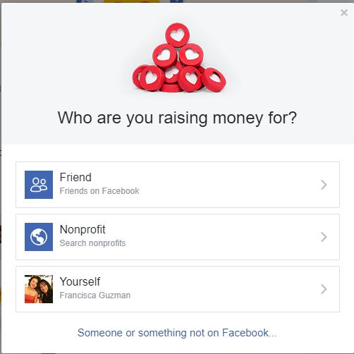
- Select Nonprofit/Charity. A pop-up will appear that will guide you through the steps.

- Select <Rescue Village> as your charitable organization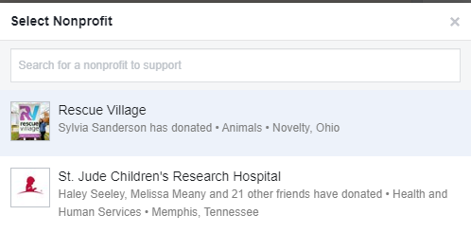
How much money do you want to raise?
Set your goal to $1,000, unless you’ve decided to raise the bar.
When should your fundraiser end?
The event wraps up at 6am on Feb. 20th. We will consider all donations received until end of day toward your goal.

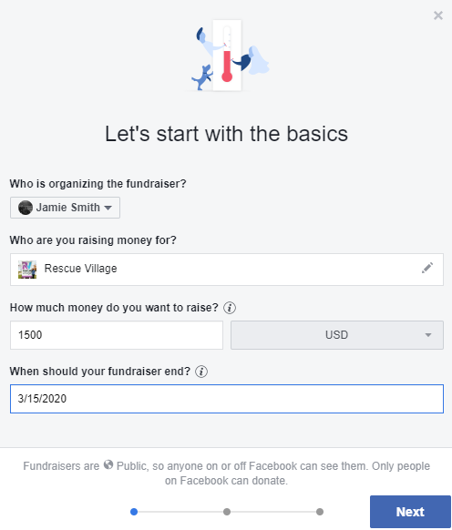

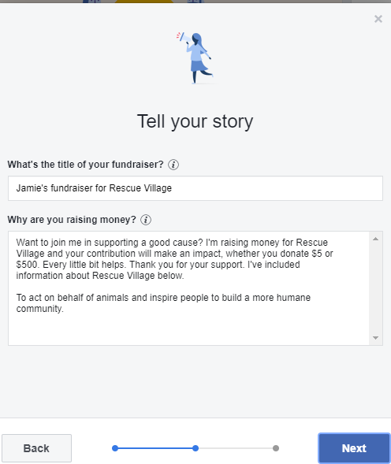
What’s the title of your Fundraiser?
Make it fun and personal to you. You can also use the event name.
Why are you raising money?
Here’s where you tell your story. Sleeping in a dog kennel is not glamorous, so share with people why supporting homeless animals is important to you. Did you adopt? Do you volunteer?

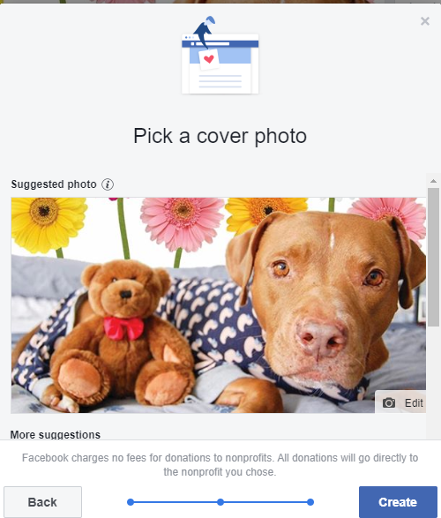
Cover Photo
The event cover photo should auto-populate or you can find the image in the Toolkit Folder. You can also upload an image or video that is unique and personal to you.
TIP: Below is a sample Facebook story to include in your fundraiser:
Want to join me in supporting a good cause? I'm raising money for Rescue Village and your contribution will make an impact, whether you donate $5 or $500.
On February 19th, I'll be sleeping in a kennel with a Rescue Village Shelter Dog or Cat as part of RV’s Slumber Party. Yes, there will be snuggles, but more importantly every dollar raised will help provide the compassionate, life-saving care that homeless animals need to get a second chance! Thanks to the work at RV, over 2000 adoptions were processed in 2020!
Leading up to the event I'll be sharing why RV and its mission are so important to me, as well as cute pictures of some of the animals available for adoption. I'll be posting updates during the event and you can catch the action on RV's Facebook Page as they stream the event LIVE. Many thanks for supporting me and a mission that is close to my heart!

What if I don’t want to use Facebook or an online donation platform?
It is not necessary to create a Facebook fundraiser in order to meet your goal. Social Media facilitates the sharing of your fundraiser and raises awareness about Rescue Village, adoptable pets, and other ways for the community to support our mission long after the event is over.
Offline Donations
Any personal or business checks or cash contributions should be given directly to you. You can bring them with you to give to Rescue Village’s Event Manager, Jamie Smith, the day of the event (or earlier if you prefer). All checks should be made payable to Rescue Village & include your name on the Memo Line.

Acknowledgement of Donations
Rescue Village will process acknowledgement letters for tax purposes for all donations received where donor information is provided. Please note, RV receives limited donor information from Facebook donations, but we will acknowledge all donors who provide an email address.
Communication Plan
Reaching out and staying in contact with your friends and family will be important to reaching your goal. You might decide that phone calls are the way for you to go, but even then, the messages below serve as good talking points. We can’t state this enough: no talking point is as great as your personal story! Tell your community why you care and why the need is urgent. Share why you decided to fundraise and why you are passionate about animal welfare. And don’t forget to tell them that you will be spending the night in a kennel!
Edit our templates and make them personal. You want your friends to know why you’ve chosen to support RV. In emails and on your social media profiles, share posts and articles that resonate with you.
Need help finding images or videos, or just in general feel a bit lost? Let us know, we can help

Email
Email is a great way to ask your friends and family to support you. You might start with emails to your close friends and family to build momentum. After that you can extend to your larger network. This can include colleagues, extended family, acquaintances, and people who share your passions/hobbies.

General Guidelines:
- Carefully select a list of recipients to email, asking them to contribute to your campaign. Think of friends, relatives, colleagues, classmates or others who typically do not see your social media activity.
- Don’t be shy! If you’re emailing people you haven’t spoken with in a while, that’s OK! They’re likely happy to hear from you anyway! Remember you aren’t asking for a gift. You’re asking people to help inspire peaceful change in the lives of shelter animals.
- Change your email signature to include a link to your fundraising page.
- After a couple of weeks have passed, it’s OK to send a reminder. (Good intentions need a helping hand!)
Email #1
Dear friends,
I’m excited to share that I’ll be sleeping in a kennel as part of Rescue Village’s Second Annual Slumber Party, a fundraiser to benefit the animals at the shelter. For 12 hours beginning at 6pm on Saturday, February 19th, I’ll be sharing a kennel with one of the dogs or cats at the shelter. Yes, I’m doing this for some snuggles, but more so because every animal deserves a second chance at a forever home.
[INSERT PERSONAL STORY—WHY IS THIS IMPORTANT TO YOU?]
Rescue Village relies 100% on philanthropic support to carry out the lifesaving work that they do for homeless animals in our community. In 2020 over 2000 animals got their second chance and were adopted to their forever homes. They are committed to saving as many lives as possible, which is why I’ve committed to raise [$1,000] to give many more animals the life-saving care they need and so richly deserve.
Would you support me during a fun, but possibly sleepless night with a sweet, loving animal by making a donation? 100% of your donation will go directly to the care of the animals at the shelter. You can also send me silly pictures of your pets and make challenges for me to complete the day of the event. I’ll be posting pictures and videos on social media, and RV will be livestreaming as well.
Thank you for supporting me and this mission that is close to my heart!
Email #2
Dear friends,
Thanks to the support of many of you, I’m [half way to reaching my goal of raising $1,000] for Rescue Village. 100% of the donations that I collect will go directly to ensuring that the animals at the shelter receive the care they need to get a second chance to find their forever home.
Please don’t forget to tune in on February 19th beginning at 6pm on RV’s Facebook page for the livestream of Slumber Party. I’m joining [X] other dog and cat lovers for a night of cuddling with shelter animals in their kennels.
[INSERT PERSONAL UPDATE—are you doing anything fun? Matching PJs? Reading a bedtime story? Challenges to raise funds during the event?]
There’s still time to make a donation to help me reach my goal. You can also help me by sharing my fundraiser with other animal lovers.
I can’t wait to share pictures and updates with you!
Again, thanks so much for your support.

Email #3
Hello everyone!
Tomorrow is the day! I’ll be spending the night with a shelter animal in his or her kennel and I hope that at the end of the 12-hours they will have a new home!
Thanks to everyone who’s supported me. With your help, I’ve [reached my goal/x away from my goal].
Again, check out the livestream on the Rescue Village Facebook page tomorrow beginning at 6pm!

Some ideas to personalize these templates:
What are you doing to prepare? What are you looking forward to? Is there a current RV adoptable dog who you want to cuddle up with? Is your RV alumnus being particularly sweet? Include pictures!

Social Media
The basics:
- Share a link to your fundraising page so friends can contribute and post updates as you get closer to your goal.
- Change your profile picture or cover photo to the RV logo and Slumber Party image. This is available in the Toolkit Folder.
- Follow us on Facebook and Instagram for stories to share how RV helps give homeless animals a second chance at a forever home.
Once you’ve set up your fundraiser on Facebook or on our Charity Engine registration link, it’s time to get sharing. Kick off the giving by making a personal donation of any amount to show just how much you care. This seed money for your campaign shows that your efforts are legitimate and communicates your ambition.
Rescue Village Social Accounts:
- Facebook Page: www.facebook.com/rescuevillage
- Event Hashtag: #RVSlumberParty
- LiveStream: Saturday, February 19th, beginning at 6pm
- Website: www.rescuevillage.org

Tips & Suggestions
- There’s no hard and fast rule on when to post, but we suggest posting 2-3 times a week in the month leading up to the Slumber Party. One post can be a direct ask and another post could something interesting or personal about RV’s mission.
  - Feel free to share posts from our Facebook page. Good shares include adoption stories. These posts usually include a photo or video which tend to have more views.
- Share progress toward your goal! After creating your fundraiser, Facebook will share it on the feeds of your friends, but posts directly from you will be more prominently featured on their feeds.
- Use social media to thank donors to your fundraiser. A shout out is a great way to help make donors feel appreciated for making an impact and reminds others to do the same.
Sample Posts
At Launch:
I’m excited to share that I’ll be participating in the Rescue Village Second Annual Slumber Party, a fundraiser for the homeless animals at the shelter. On February 19th, I’ll be spending the night in a dog kennel with a shelter dog (or cat)! My goal is to raise [fundraising goal] to help provide the care homeless animals need to have a chance at a forever home. [Insert photo] #RVSlumberParty
During:
• An overview of what RV does to help homeless animals find their forever homes: Last year, RV provided care to more than 2,500 animals. Help me reach my goal of [x] so that we can help even more homeless animals. [Insert Photo] #RVSlumberParty
• A post on your adoption story or successful RV adoption
• Valentine’s Day Post: Share your pet’s love. Post a photo of you and your pup snuggling. Help more animals find their forever home by supporting the #RVSlumberParty.
• What are you most looking forward to about the Slumber Party?
I’ve got my PJs and my favorite blanket ready to get cozy with an RV shelter pup on Saturday February 19th. I’ll be spending the night in a kennel for 12 hours to help fundraise
much needed funds to continue to care for the animals at the shelter. [Insert Photo] [Link to Fundraiser] [Link to Donate] #RVSlumberParty
Day of:
Today is the day! Catch the live stream of the RV Slumber Party on their Facebook page beginning at 6pm. Looking forward to [something special you’re planning to do/ “meet my kennel mate” for the night]. #RVSlumberParty
End/After:
Thank you for making a difference in the lives of Rescue Village’s homeless animals. You helped me reach my goal of raising [x] for Rescue Village. And the best part is that I got to spend the night with [animal name]. [Something fun about that night] [Is he/she adopted?] [Insert photo from event] #RVSlumberParty
Business Sponsorships
What if I feel like I’ve maxed out my friends and family?
It’s perfectly natural to feel this way. We often have more than one cause that’s important to us, and we tend to go to the same people for support. One idea is to seek sponsorships from local businesses to help reach your goal.
In the Toolkit Folder, you will find a template letter for you to take to local businesses along with a flyer that tells them what the event is about.
Tips:
- Ask businesses that you frequent and support. This could be your local coffee shop, accountant, hair salon—anyone with which you have a relationship with. At the same time, don’t be afraid to ask a business that you think might support RV’s mission.
- Find out who the decision maker is and speak with them. This is often the manager, but depending on the business they might have specific forms or protocols to follow for donations.
- Share with them how they will be recognized. Ideas to recognize businesses and offering them publicity benefits include:
  - Giving them a shout out on Facebook.
  - Including their logo as part of your kennel décor the day of the event
  - Verbal recognition during the livestream portion of the event on RV’s Facebook Page
  - RV will recognize all business sponsors on:
    - RV social media
    - RV website
    - Acknowledgment letter from RV for tax-purposes
- Thank them! Yes, you gave them a shout on Facebook, but don’t forget to send them a thank you note after the event. Share something fun about the night and your donation total.

Matching Donations
Another fundraising tactic is to offer a “matching” donation. You can either personally offer a match or get a donor to offer a match on all or a portion of the donations that you receive. For example, you can let potential donors know that you will personally match up to the first $1,000 donated to your campaign or that you have an anonymous donor who will match up to the first $2,000 in donations. Donors love feeling like their donation is being doubled and in our experience, they are more likely to donate more so it will go even further to help the animals.

Frequently Asked Questions
How will donations be used?
All monies raised through the Slumber Party will go directly towards providing care for the shelter’s animals. This includes vaccinations, shelter, spay & neuter services, foster care supplies and support, life-saving medical care, and much more.
Are donations tax-deductible?
Yes, all donations made to RV are tax-deductible to the extent allowed by law.
Will RV send acknowledgement of donations?
Yes, RV will send acknowledgement letters for all donations received that have sufficient donor information. For online donations made through Facebook, RV receives donor information only if the donor provides it. You can send information for the donors to your personal fundraiser if you would like RV to send thank you letters.
That said we encourage all participants to thank their donors personally. Yes, they’re supporting RV, but they’re also supporting YOU!
Where will the event be livestreamed?
The event will be livestreamed on RV’s Facebook page beginning at 6pm on Saturday February 19th for about 4 hours. You can choose to livestream directly to your friends from your Facebook account and RV will share your feed.
Livestream details and time frame will be shared closer to the event.
What do I need to bring with me?
Admittedly, we think there won’t be much sleeping that night, but feel free to bring anything that might make it more comfortable for you. Beach chairs, cots, sleeping bags, etc. can be brought into the kennel. Remember, the kennel is not very big and you will be sharing it with a dog/cat.
There will be a designated area for you to store personal belongings you might need during the night that you do not want to have out in the kennel. This can include toiletries, medications, change of clothes, etc.
What happens if I don’t meet my goal?
This is first and foremost about having fun! Yes, we want to meet our goal because it means we can help more animals. Yet, every penny counts toward this, so just do the best you can!

